DEC1606
Josh Abbot - Micron
Dr. Chinmay Hegde
Cameron Cornick / Team Lead
Ashlyn Freestone / Communication Leader
Wen-Chi Hsu / Webmaster 1
Yiru Gao / Webmaster 2
Zach Snyder / Key Concept Holder
DEC1606@iastate.edu

Revised: 02.20.2016

Voice for Autism
  - Project plan
Contents
1 Introduction 2
1.1 Project statement 2
1.2 purpose 2
1.3 Goals 2
2 Deliverables 2
3 Design 3.1 Previous work/literature 3
3.2 Proposed System Block diagram 3
3.3 Validation 4
4 Project Requirements/Specifications 5
4.1 functional 5
4.2 Non-functional 5
5 Challenges 5
6 Timeline 6
6.1 First Semester 6
6.2 Second Semester 6
7 Conclusions 7
8 References 7
9 Appendices 8

1 Introduction

1.1 Project statement
In a world that is bereft of affordable alternatives for families with a member diagnosed with autism. There is an extreme lack of a device that can travel and grow with the user at an affordable price. This would entail a customizable, welcoming, and durable device that will last through the trials and tribulations of a growing human.

1.2 purpose
The purpose of this project is to improve the standard of living of those with disabilities as well as the deficit of lower income families.

1.3 Goals
Some of our goals are to make a device that is customizable for those of all ages, to make the device welcoming and inviting. We want a device simple enough for those of all levels of autism to use, as well as a wider market of other individuals who could utilize an assistive communicative device. The device should be able to withstand rough conditions such as dropping and throwing. The finished project should not cost more than $200 to produce, to make it more affordable. The device will need to be battery operated so it can travel with the customer where ever they go.

2 Deliverables
The product that will be delivered will include multiple different packages available. These will be targeted for various degrees of need for the user and their caretakers. The product will be any combination of the following starting with an app that can be run on the phone for those able to safely use phones. The package can then be ramped up to a device offering that will be built and setup with the application to with stand the rigors of heavy use. The last part of our product will be to provide analytics on the usage of the device to provide better service from caregivers.

3 Design
3.1 Previous work/literature
There are two different types of devices out there for those with autism; one that is low ease of use (outdated) and another that is more technologically advanced. The outdated product consists of a card being slid into a device for the customer to communicate. However, multiple cards would be needed in order for them to communicate effectively. These devices range from $200 to $600 (Google). The technologically advanced devices can be split into two additional categories; low level and high level autism. Those with high level autism may have the ability to carry around the device with them, and are more mobile. These devices will need to stand up to rougher conditions such as dropping and throwing. However, those with lower level autism may not be as mobile and will need ta stand to hold the device for them to be able to use it. This may not be put through the same amount of rigorous activities as that one of high level autistic ability. These devices range from $600 to $8500.
Investigating features that are possible there was found voice recognition software that has already been developed. “Siri”, the Apple personality and program, is a good example of voice recognition and voice generation. There is also the word suggestions that has been utilized to increase the speed and accuracy of text communication, these are exemplified in such places as GoKeyboard.
This section will continue to grow as we continuously expand our research.

3.2 Proposed System Block diagram
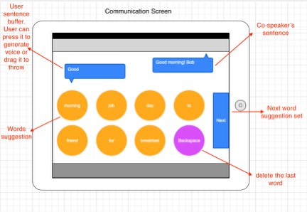

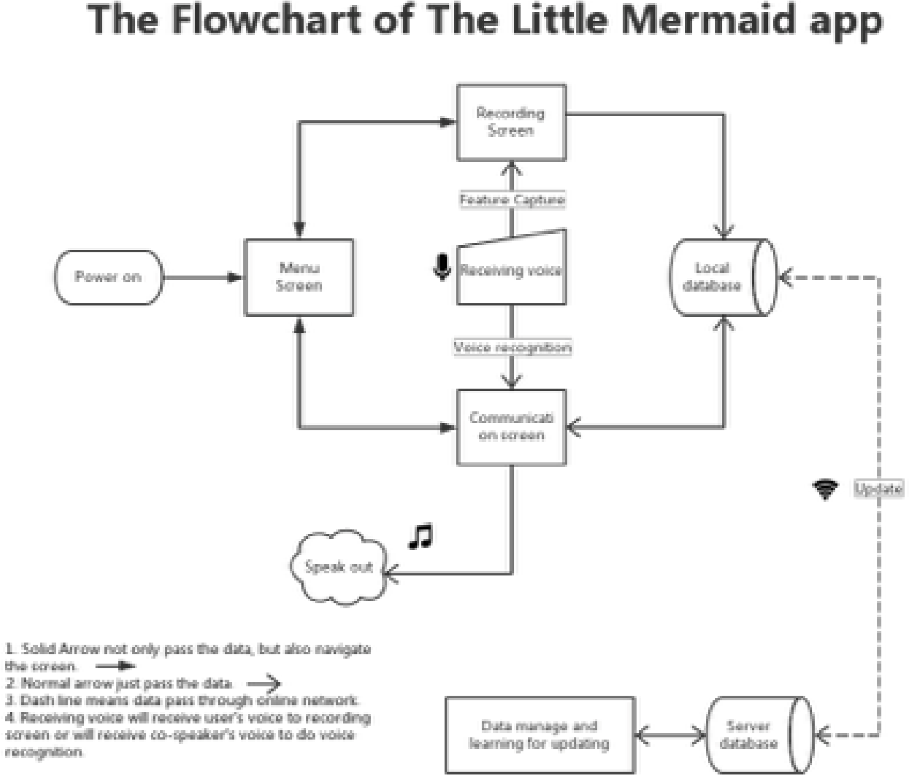

3.3 Validation
We will test our device heavily with user feedback as a lot of our design criteria depends on the user. Other aspects of the device will be tested with either “drop” tests or other hardware/software tests.

4 Project Requirements/Specifications

4.1 functional
- Robust
- Battery Operated
- Touch Screen
- Audio In/Out
- Audio out from App
- Voice Recognition
- Word Suggestions

4.2 Non-functional
- Customizable
- High Ease of Access

5 Challenges
We believe that a big challenge will be the enclosure. This is because it is something that has been outside of our expertise. This may be an issue as far as the ruggedness and customizability that is desired into the enclosure. The other big challenge is the ambitious follow up to the application of creating a voice recognition and word prompt for the user. This would involve a lot investigation and trial and error.

6 Timeline

6.1 First Semester
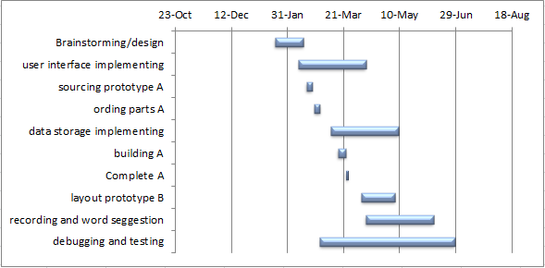The goal for the first semester is to have a working prototype to demo that the hardware and software configuration will be able to satisfy the needs and desires of the user at the basic level.

\\

6.2 Second Semester
The goal for second semester is to have a fully functioning device that has been tested and proven to stand up to the rigors of use. This entails a fully qualified device enclosure and the ability customize the application. There will also be voice recognition and a much deeper personalization for the application allowing the streamlining and precision of the communication.
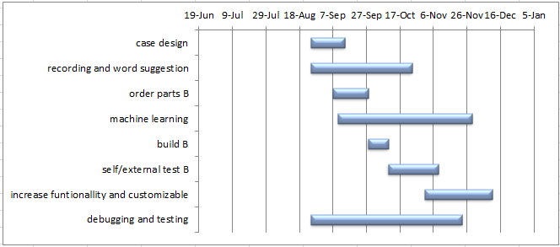

7 Conclusions
“A Voice for Autism” as a project is aimed at fitting into and providing a large benefit for the consumers. It is meant to supply a rugged and customizable device that can grow and engage the user to bring them into this world as a functioning individual. This is important and vital to a growing world where every voice is valuable and meaningful to bring the world into a new age of prosperity.

8 References
//TODO: organize references into a coherent bibliography
http://www.augcominc.com/whatsnew/ncs5.html
https://en.wikipedia.org/wiki/Augmentative_and_alternative_communication
http://www.aacandautism.com/why-aac
http://www.theoatc.org/resources/documents/AACSystemHandout2013.pdf
http://www.acciinc.com/dynamic-display-text-to-speech/?sort=priceasc

9 Appendices
Various Charts and Concept Drawings:
